AIM:

To write an R program to print a multiplication matrix

ALGORITHAM:

* Define a function that takes n as input
* Use two nested loops to iterate through the row and columns from 1 to n
* In each loop multiply the current row number with the current column number
* Once the matrix is filled print the multiplication matrix

PROGRAM:

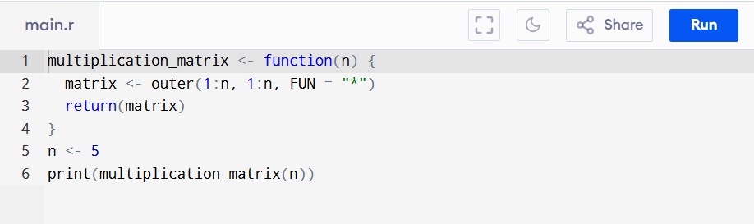

Out put:

